2022-2023 Season
IntroStar/StarSkate Registration
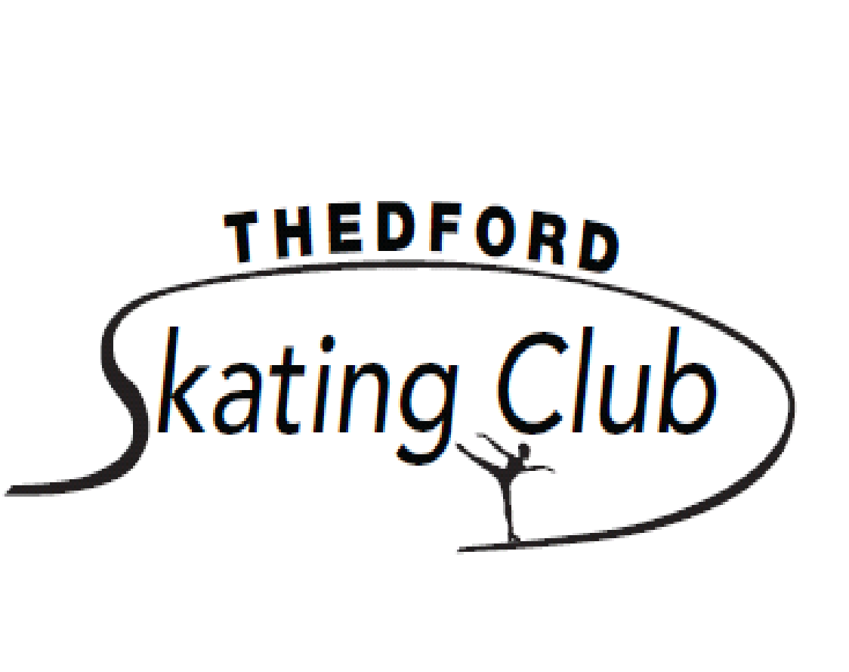

Please complete one for per skater.

Skate Last Name:_________________ ____First Name:______________
Birth date:(DD/MM/YYYY)_______________________________Gender: M F
Address:______________________________
City:_________________________________Postal Code:_______________

Health Concerns/Allergies:________________________________________
Parent(s)/Guardian(s) Names:_____________________________________
Phone Number:_____________ Cell Number:______________
E-mail Address:_____________
Emergency Contact:_________________Phone Number:________________

Are you a new skater to Thedford Skating Club? Y N
Is this your home Club? Y N If No, Name of home/previous club:________
Skate Canada #_____________________
Last Badge/Level:___________________
Skate Canada Test Level:_____________
Skill: Dance:___________Free Skate:________________________

Do you wish your child to be involved in the year-end Carnival? Yes No

Do you give permission for your child’s pictures to be taken and used?
in the local media/club website/newspaper/bulletin board, etc.? Yes No

Is your child 10 years of age or older and interested in being a program
assistant? Yes No

Do you give permission for the club to contact you through your email?
address? Yes No

Do you qualify for financial support to help with costs of registration, if so please
contact us for more information. Yes No

PAGE 1 OF 2

PROGRAMS AND DATES:

WEDNESDAY and SATURDAY
IntroStar 4:30 pm to 5:15 pm 9:00 am to 9:45 am

StarSkate 5:15 pm to 6:05 pm 10:40 am to 11:50 am

Registration Fees :
2022/2023 Sessions Fee $380.00
Skate Canada Fee (includes insurance, non-refundable) $ 45.00
Total $425.00

Please make all cheques payable to the Thedford Skating Club and mail to PO Box 217, Thedford, Ontario N0M 2N0 or e-transfer to thedford.skating@gmail.com

* Regular season begins October 5, 2022 to April 2, 2023.
* Families with more than 2 children receive a discount of 50% off the session fee for additional children (not including Skate Canada Fee)

I, __________________, consent to (skater’s name)_______________________ participating in the activities of the Thedford Skating Club and hereby release and forever discharge the Thedford Skating Club and its agents, being all coaches, directors, officers, volunteers, members, staff successors and/or assignees of and from all claims, damages, actions or causes of action arising by reason of the participation of the skater in skating or other club activities and from all claims or demands whatsoever in law or equity which I , my heir, executors, administrators or assignees can, shall or may have because of such participation. By signing below, I have read and agreed to the above indicated registration, refund, liability and publicity consent policies and/or statements.

DATED AT Thedford THIS ______ DAY OF ____________, 2022

Signature of Parent or Guardian:_________________________

Club Authorization:____________________________________

An additional $35.00 charge for NSF cheques, all registration fees must be paid in full by December in order to continue onto the winter session starting in January. The Thedford Skating Club reserves the right to cancel or change schedule due to weather and blackout dates.

PAGE 2 OF 2

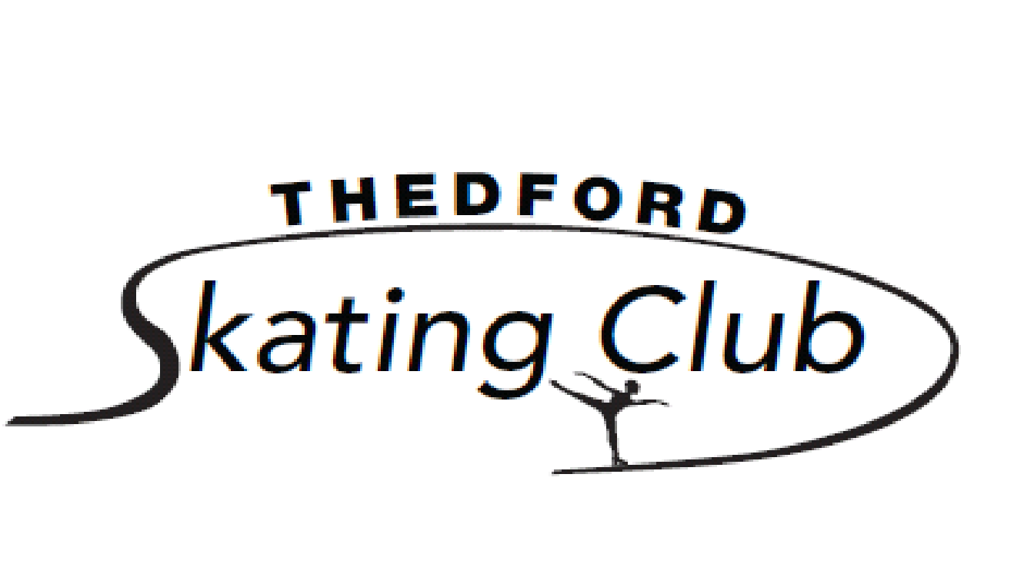

2022/2023 Skating Session Family Obligation

Family Name:________________ __ Skaters:______________________
Parents/Guardian:_______________ ______________________
Phone :_______________________ ______________________

Each Family is required to pay the appropriate registration fee per child, plus provide cheques (per family not per child) for the following:

FAMILY OBLIGATION | AMT | PAID | RETURNED
Cash Calendar  Post dated cheque January 1, 2023 | $100
Family Surcharge  Post dated cheque April 30, 2023– returned at AGM | $ 50
Fundraising Opt Out  or Post dated cheque April 1, 2023 (net sales $100) | $100
Volunteering Opt Out  or Post dated cheque April 1, 2023 (4 hours) | $100

There will be a charge of $35 for each NSF cheque

Skater’s Code of Conduct

Skating is a competitive and individualized sport which requires safe and courteous behaviour from all participants, on and off the ice. Skaters need to be aware of one another and react predictably to ensure their own and other's safety. Each skater is responsible for being aware of and practicing the rules of etiquette and safety noted below.

GENERAL BEHAVIOUR
- Due to insurance requirements, only registered Skate Canada members are permitted on the ice, except in a medical emergency.
- Food, drink, and gum are not permitted on the ice. Water bottles are acceptable but must be left at the board. Glass bottles are prohibited.
- Spectators, including parents of skaters, may watch from the stands or seating area, but not by the boards. They must refrain from conversing with or offering direction to the skaters on the ice. (If a skater needs more direction, the coach should be consulted after the session and a plan developed to help the skater become more independent.)
- The doors along the rink must be kept closed while a session is in progress to ensure the safety of the skaters on the ice. Sitting on the boards is not permitted.
- Skaters must clear the ice promptly at the end of each session.

BEHAVIOUR ON THE ICE
- Skaters are expected to be skating at all times while on the ice. They are expected to get up promptly after a fall in order to keep pathways clear for other skaters.
- The ice surface should be used for practice and not for conversation. Working in small groups with a coach’s approval is acceptable.
- When practicing routines, skaters must learn to maneuver around other skaters and still complete jumps, spins and footwork successfully. The skater whose music is playing at that time has the right of way. Calling out “Excuse me!” or “Heads up!” will alert other skaters to get out of the way.
- Foul language, yelling, abusive or aggressive behavior, including kicking holes in the ice is prohibited and will result in loss of club privileges.

SKATE CANADA POSITION STATEMENT ON BULLYING taken from www.info.skatecanada.ca
Skate Canada strongly condemns bullying, will not tolerate bullying by any of its members and is committed to raising awareness of this issue and preventing and eliminating bullying behaviour within Skate Canada. Skate Canada recognizes that bullying can have a serious adverse impact on personal dignity, self-esteem, confidence, personal safety, performance, enjoyment of skating and of life itself.

All Skate Canada members have the right to participate in a safe, supportive and caring environment free from harassment and they have the responsibility to contribute to the protection and maintenance of this environment.

Bullying is a form of personal harassment and includes physical or verbal abuse that occurs once or repeatedly and may involve an imbalance of power. Bullying is intended to hurt and humiliate the victim and my include:
- Insulting or derogatory remarks or gestures
- Rude or vulgar language or gestures
- Shouting, yelling, swearing, name calling
- Persistent unwarranted criticism
- Public ridicule
- Verbal, written or physical threats and intimidation
- Hitting, kicking, pushing or other types of forceful physical contact
Bullying may occur in person or through electronic means including email, texting and social media.

If a Skating Club member has experienced bullying behaviour, or has witnessed another member being bullied, the member may submit a complaint to the Complaint Review Officer at the Skate Canada national office as per the process in the Skate Canada Membership Complaints, Hearing and Investigation Procedures Policy. Skate Canada recommends that all of its member clubs and skating schools post this document on their club/school notice boards and/or website and make it available for members upon request. Every member club and skating school will inform its athletes, coaches, officials, and volunteers of this document and will encourage victims of bullying, and the parents of victims of bullying, to bring forward these items as per the above mentioned process so that all necessary and reasonable steps to stop and prevent bullying behaviour can be taken.

